AGGREGATION FUNCTIONS

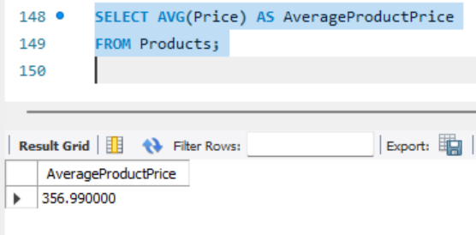

GROUP BY

HAVING CLAUSE

